**MATH 2050 Homework 2**

**Please return your completed homework to the Assignment Box by Sunday, February 9, 11:59pm**

1. Suppose that you randomly selected 50 students at GGC and collected data on the following five variables

U: Number of courses the student is taking this semester

V: The student’s class

X: The number of hours per week the student plans to study

Y: The total cost of textbooks

Z: Method of payment for textbook

Questions:

a) What is the population? All students at GGC

b) Is the population finite or infinite? Finite

c) What is the sample? 50 randomly selected students at GGC

d) Classify the five variables as either discrete, continuous, nominal or ordinal  
U: discrete – The number of classes the student is taking will be a whole, countable number.

V: ordinal – The class the student is taking can be ordered by way of level or perquisite classes.  
X: continuous – The number of hours per week the student plans to study can be broken down into fractions of an hour which can always be reduced.

Y: discrete – The total cost of textbooks will be in a whole number of cents. Cents are not broken down further, so variable is not continuous.

Z: nominal – The method of payments the student could make does not inherently include a logical order.

1. Classify the following variables as either discrete, continuous, nominal or ordinal:

a) The speed at which individuals from the southern part of the United States can shoot a hockey puck. – Continuous; speed that the puck is shot is measured in a continuous length of time.

b) A poll of registered voters as to which candidate they support –

Nominal; which candidates a voter supports does not inherently include a logical order.

c) The number of pages per job coming off a computer printer – Discrete; number of pages will be a whole number of countable pages.

d) The ranking individuals gave to the movie the “The Matrix” (from Hated it to The Greatest Movie Ever) – Ordinal; ranks received can be placed in an order of low grades to high grades.

1. Suppose that a random sample of the times, in hours, 30 students spend studying for the 1st test in Calculus is:

4.00 3.75 2.25 1.46 7.83 4.23

9.58 6.28 1.93 8.29 10.85 0.43

5.29 4.64 9.94 2.13 6.38 5.21

7.34 6.48 1.23 9.99 10.83 3.67

0.25 8.45 7.39 5.23 5.34 3.34

1. Using intervals of 0-0.49, 0.5-0.99, 1.0 – 1.49, 1.5 – 1.99, 2.0 – 2.49, …, construct a histogram. What is the “shape”?  
   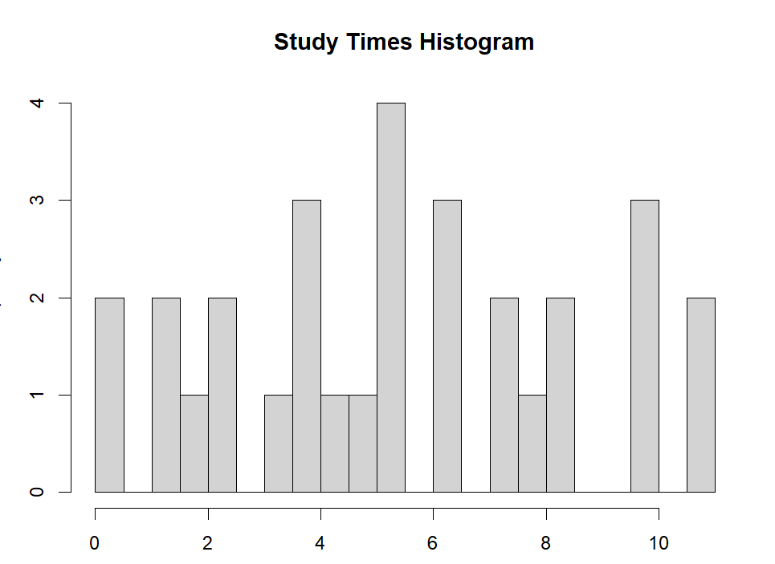  
   Shape appears to be multi-modal
2. Using intervals of 0-0.99, 1.0 – 1.99, 2.0 – 2.99, 3.0 – 3.99, …, construct a histogram. What is the “shape”?  
   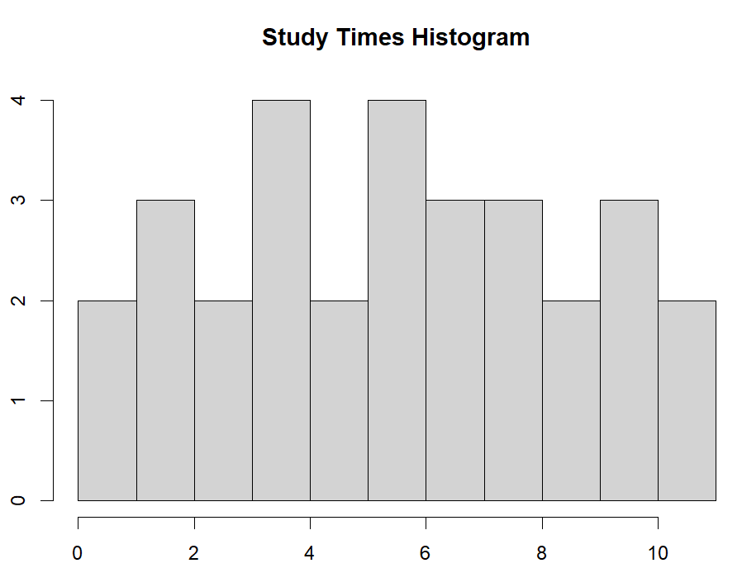  
   Shape still appears to be multi-modal
3. Using intervals of your own choosing, construct a histogram. What is the “shape”?  
   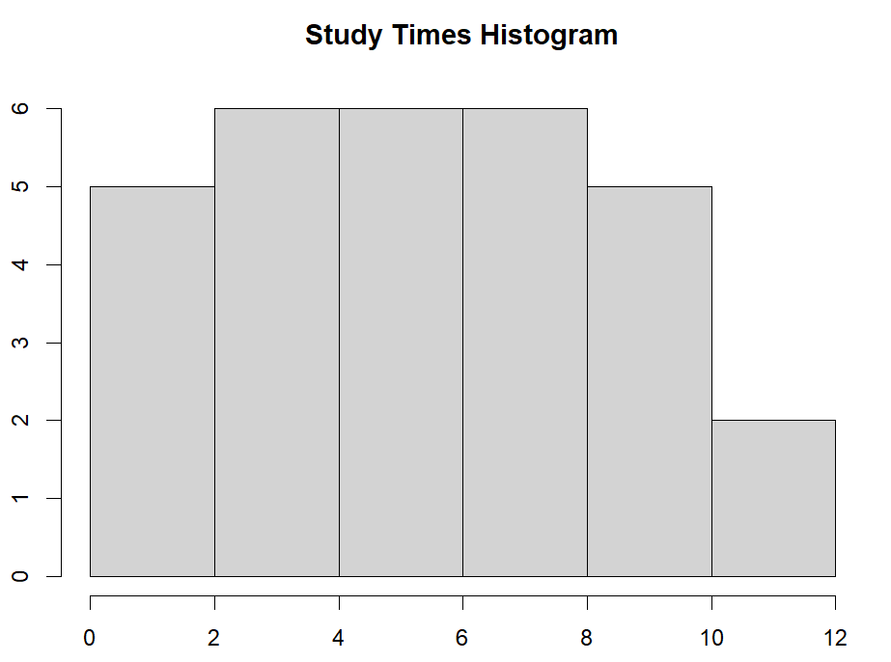  
   Shape is skewed right
4. What is the skew of this data from the computer?

Skew is to the right

1. A psychiatrist has developed a measurement instrument for the mental state of patients. The test is on a scale of 0-100 (with higher scores meaning the patient is suffering from a higher level of mental duress). She randomly selects a group of individuals to take part in a study using this measurement instrument, and she develops a stem-and-leaf plot of her data as follows:

0 | 6

1 | 1178

2 |

3 | 0017899

4 | 2

5 | 67788999

6 |

7 | 114444499

8 | 889

9 | 01

Based on the stem-and-leaf plot, answer the following questions:

* 1. What is the mean, median, midrange and mode?
     1. Mean: 55.6
     2. Median: 58.5
     3. Midrange: 48.5
     4. Mode: 74
  2. What is the range, variance and standard deviation?
     1. Range: 85
     2. Variance: 627.2
     3. Standard Deviation: 25
  3. What is the 25th percentile? What is the interpretation of this value?
     1. 25th percentile: 37.75
     2. Interpretation: 25% of the patients scored lower than 37.75
  4. What is the 75th percentile? What is the interpretation of this value?
     1. 75th percentile: 74
     2. Interpretation: 25% of the patients scored higher than 74
  5. What is the interquartile range (IQR)?
     1. IQR: 36.25
  6. What is the z-score for a patient that scores 88? What is the interpretation of this z score? On the basis of the z score, would you classify the “88” measurement as an outlier? Why or why not?
     1. Z-score: 1.296
     2. Interpretation: z-score of 1.296 is within 2 standard deviations, which indicates that it should not be considered an outlier.
     3. 88 is not an outlier, as it does not significantly deviate from the expected values and is within range of the box-and-whisker plot.
  7. Construct a box-and-whisker plot

